Question 1. Marks

(a) Find (i) 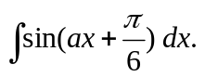 1

(ii) 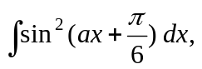 where a is a constant. 2

(b) Find 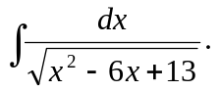 3

(c) Evaluate 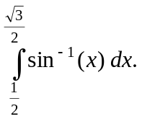 3

(d) (i) Given that 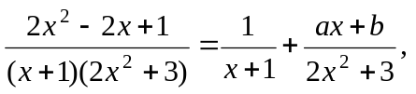 2

find the real numbers a and b.

(ii) Hence, or otherwise evaluate 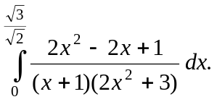 4

Question 2. [START A NEW PAGE]

- Given 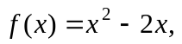sketch the graph of the following on separate axes

(i) 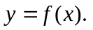 1

(ii) 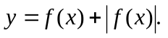 2

(iii) 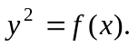 2

(iv) 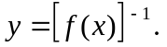 2

(v) 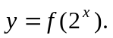 2

(b) (i) For the Hyperbola: H: 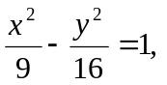 find its eccentricity e. 2

- Hence, neatly sketch the graph of H, clearly showing the 4
vertices, foci, directrices and asymptotes.
Question 3. [START A NEW PAGE] Marks

- An ellipse E has the equation: 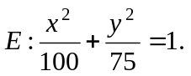

(i) Sketch this ellipse, clearly showing on your diagram the 4
coordinates of the foci and the equation of each directrix.

(ii) Show that the equation of the normal to the ellipse E is 2
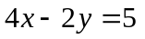 at point 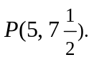

(iii) A circle is tangential to the ellipse E at P and at 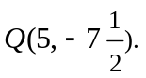 1
Show that the centre of the circle is 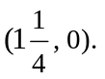

(iv) Hence find the equation of this circle. 2

- Using the substitution: 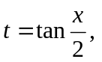where 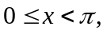show that: 4

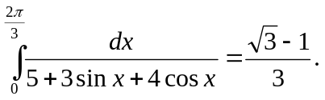

(c) For x > 0, find: 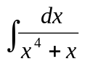. 2
Question 4. [START A NEW PAGE] Marks

- The point 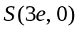is a focus of the hyperbola H: 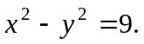
The tangent to the hyperbola, at the point P(p, q), meets the asymptotes
of H in T and W, as shown in the diagram below.

y
Not to scale

O
x

- Show that the equation of the tangent TW is given by: 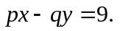 1

- Show that the gradient of the line through SW is given by 1
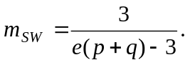

(iii) By letting 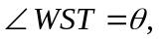find the value of 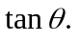 3

- Let 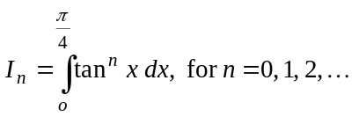

  - Show that 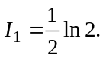 2

  - Show that, 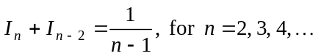 3

  - Explain why 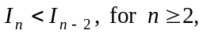and deduce that 3

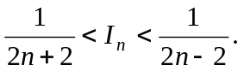

  - By using the recurrence relation in part (b) (ii), 2
find 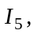and deduce that: 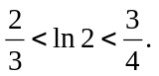

THE END
☺ 😐 ☹

